Chapter 16, Solution 41.

Find the output voltage v_{o}(t) in the circuit of Fig. 16.64.

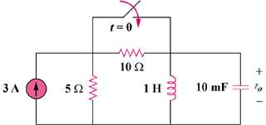

Figure 16.64
For Prob. 16.41.

Solution

Step 1. First we need to determine the initial conditions. We see that v_{o}(0) = 0 since the inductor becomes a short. We also note that the initial current through the inductor is the same as the current through the 10 Ω resistor or i_{L}(0) = [3(5x10)/(5+10)]/10 = 1 amp. Then we simplify the circuit and convert it into the s-domain and solve for V_{o}. We then perform a partial fraction expansion and convert into the time domain.

5 Ω

3/s

s

1/s

100/s

V_{o}

–[3/s] + [(V_{o}–0)/5] + [(V_{o}–0)/(100/s)] + [(V_{o}–0)/s] + [1/s] = 0.

Step 2. [0.2+(s/100)+(1/s)]V_{o} = 2/s = [(s²+20s+100)/(100s)]V_{o} or

V_{o} = 200/[(s+10)²] and

v_{o}(t) = [200te^{–10t}]u(t) volts.

